**Target site: indrive.com**

**Scanning the open ports using Nmap:**

┌──(root㉿kali)-[~]

└─# nmap indrive.com

Starting Nmap 7.92 ( https://nmap.org ) at 2023-06-20 18:23 IST

Nmap scan report for indrive.com (185.104.210.6)

Host is up (0.031s latency).

Not shown: 989 filtered tcp ports (no-response)

PORT STATE SERVICE

21/tcp open ftp

25/tcp open smtp

80/tcp open http

110/tcp open pop3

113/tcp closed ident

143/tcp open imap

443/tcp open https

2000/tcp open cisco-sccp

5060/tcp open sip

8008/tcp open http

8010/tcp open xmpp

Nmap done: 1 IP address (1 host up) scanned in 14.06 seconds

Screenshot:

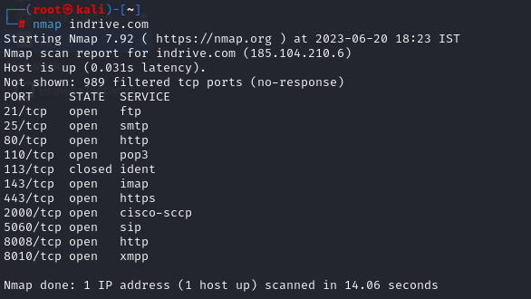

**Target site: acunetix.com**

**Scanning the open ports using Nmap:**

┌──(root㉿kali)-[~]

└─# nmap acunetix.com

Starting Nmap 7.92 ( https://nmap.org ) at 2023-06-20 18:33 IST

Nmap scan report for acunetix.com (34.238.213.100)

Host is up (0.042s latency).

Other addresses for acunetix.com (not scanned): 54.156.129.192

rDNS record for 34.238.213.100: ec2-34-238-213-100.compute-1.amazonaws.com

Not shown: 988 filtered tcp ports (no-response), 1 filtered tcp ports (admin-prohibited)

PORT STATE SERVICE

21/tcp open ftp

25/tcp open smtp

80/tcp open http

110/tcp open pop3

113/tcp closed ident

143/tcp open imap

443/tcp open https

2000/tcp open cisco-sccp

5060/tcp open sip

8008/tcp open http

8010/tcp open xmpp

Nmap done: 1 IP address (1 host up) scanned in 15.69 seconds

Screenshot:

